2018 “Dare to Dream” team instructor/mentor guidelines
With the assistance of your D2D team coach, you are advised to follow this preparation outline.
- (Session 1) Review problem/opportunity-based strategic planning tool (Canvas Attachment 1)
- (Session 2) Review last year’s presentations with the judging guidelines as a student activity to evaluate the past pitches and learn from them. Here is the link to the past pitches. End with a session to brainstorm problem/opportunities with teams.
- (Session 3) Bring back research on multiple problem/opportunities, having explored the following questions for each (in broad, overview fashion)
  - Who does this problem/opportunity effect (customers)?
  - How big a problem/opportunity is this (market)?
  - Is anyone else providing a solution to this problem/opportunity (competition)?
  - How would you get from an idea to a viable product/service (milestones/timeline)?
  - How much would it take to get there (capital requirements)?
- (Session 4) Finalize choice of your concept and do group research on outlying concerns raised by the answers to questions in #3. Work on the ‘elevator pitch’ (see Attachment 2).
- (Session 5) Start work on the presentation using the matrix in Attachment 3 (one slide per line item)
- (Multiple Sessions) Continue to work on the presentation and practice the pitch. Keep pitch practices as genuine and realistic as possible. The past years pitches can be reviewed to see possible formats.
- (Second-to-last Session) dress rehearsal of the pitch and questioning of judges with your coach, mentors, and at least one invited guest unfamiliar with the pitch from beginning to end; feedback and homework for revisions. Make sure to incorporate mock questions for the pitch team. The judges will be asking the students questions and the students need to practice the correct format of answering clearly, respectfully, and honestly. Draw example questions from previous year’s pitches and the unfamiliar guest.
- (Final Session) Final dress rehearsal with revised pitch

APPENDIX ONE: CANVAS











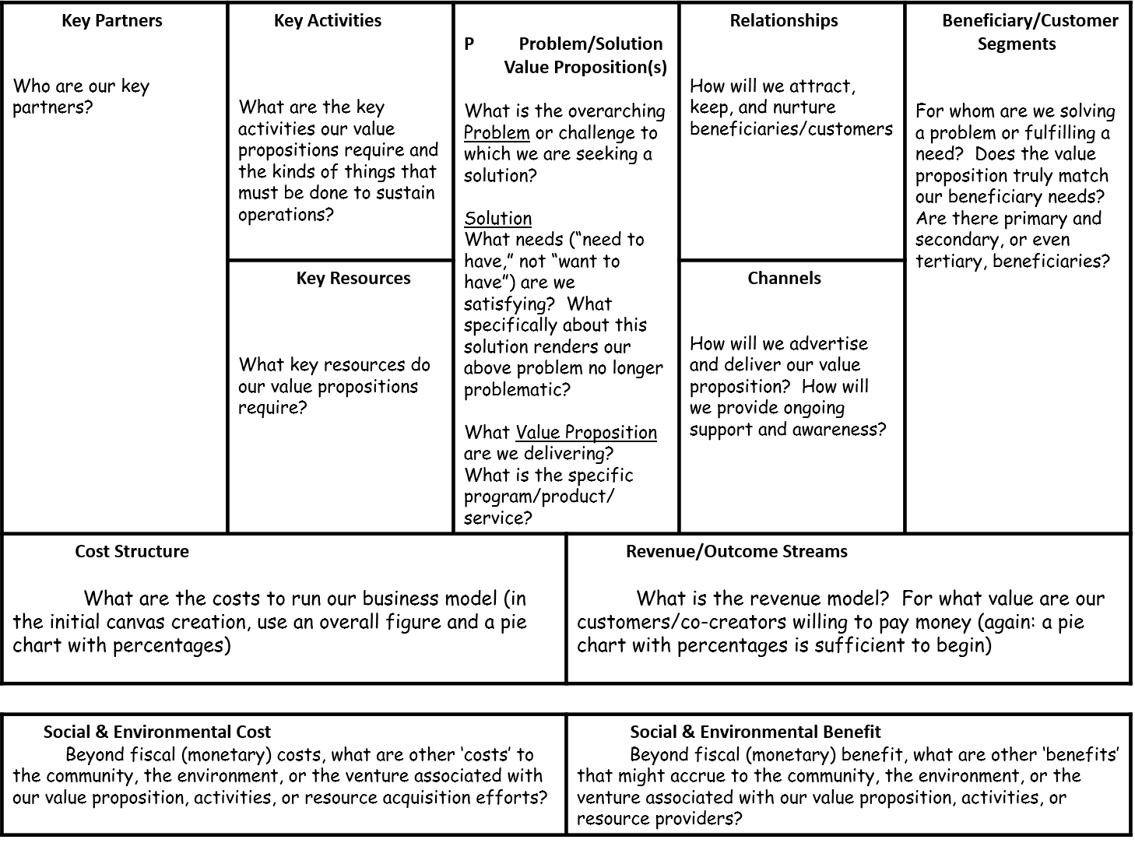

APPENDIX TWO: ELEVATOR PITCH

The Perfect (60 sec) Pitch
What value do you provide?

An elevator pitch is an overview of who you are, what you do and how you can help the listener. It is not a business plan or a summary of one; it is a ‘come on’ to garner interest in more detail.
A successful elevator pitch does several things:
- Opens with a ‘hook’ to capture the listener’s attention
- Is clear and doesn’t use too much industry jargon
- Is memorable
- Is no longer than two sentences, or about 60 seconds.

How do you provide this value?

What is different about what you offer?

To whom do you offer value?
Craft Your Pitch
SAMPLE FORMAT: For (what is your target market/segment/group?) who (what is the problem your target has that your value solves?) our (what is your product/service/thing of value?) is a (plain English statement of your product/service category) that (what special value does it deliver?) unlike (who is/are your dominant competitors), our product delivers (details about your how your are special)? Bonus: say why your listener will find this story interesting; what is in it for them: money? Recognition? Social good?)
- Begin with an action phrase that is NOT a noun
- Add a one sentence statement about what you DO
- Give a statement of the SPECIFIC IMPACT

Your Pitch:
For ________________________________________________________________ who _________________________________________________our________________________ is a ____________________________________________ that ________________________________ unlike _________________________________.
Sample pitch for a new village maternity facility:
“For all our community members ages who want a local, personally-connected, capable, clean, medically-connected location to deliver new babies, our midwife-run new Maternity House is a clean, trusted establishment with careing medical staff and instant connection to qualified doctors that enables instant access to medically-trained doctors via 24/7 internet connection. It is unlike any existing facility because it is extremely low cost and permits family attendents. It is immediately open for new mothers-to-be.”
Sample pitch for a known commercial product:
“For computer users of all ages who want a connected, application-rich mobile computer device, our iPad is a light, easily-carried and cutting-edge technology that enables instant access to work and gaming. It is unlike any existing laptop or other mobile computing device, delivering immediate gratification at affordable prices for a market of 250 million users within its first six months on sale.”

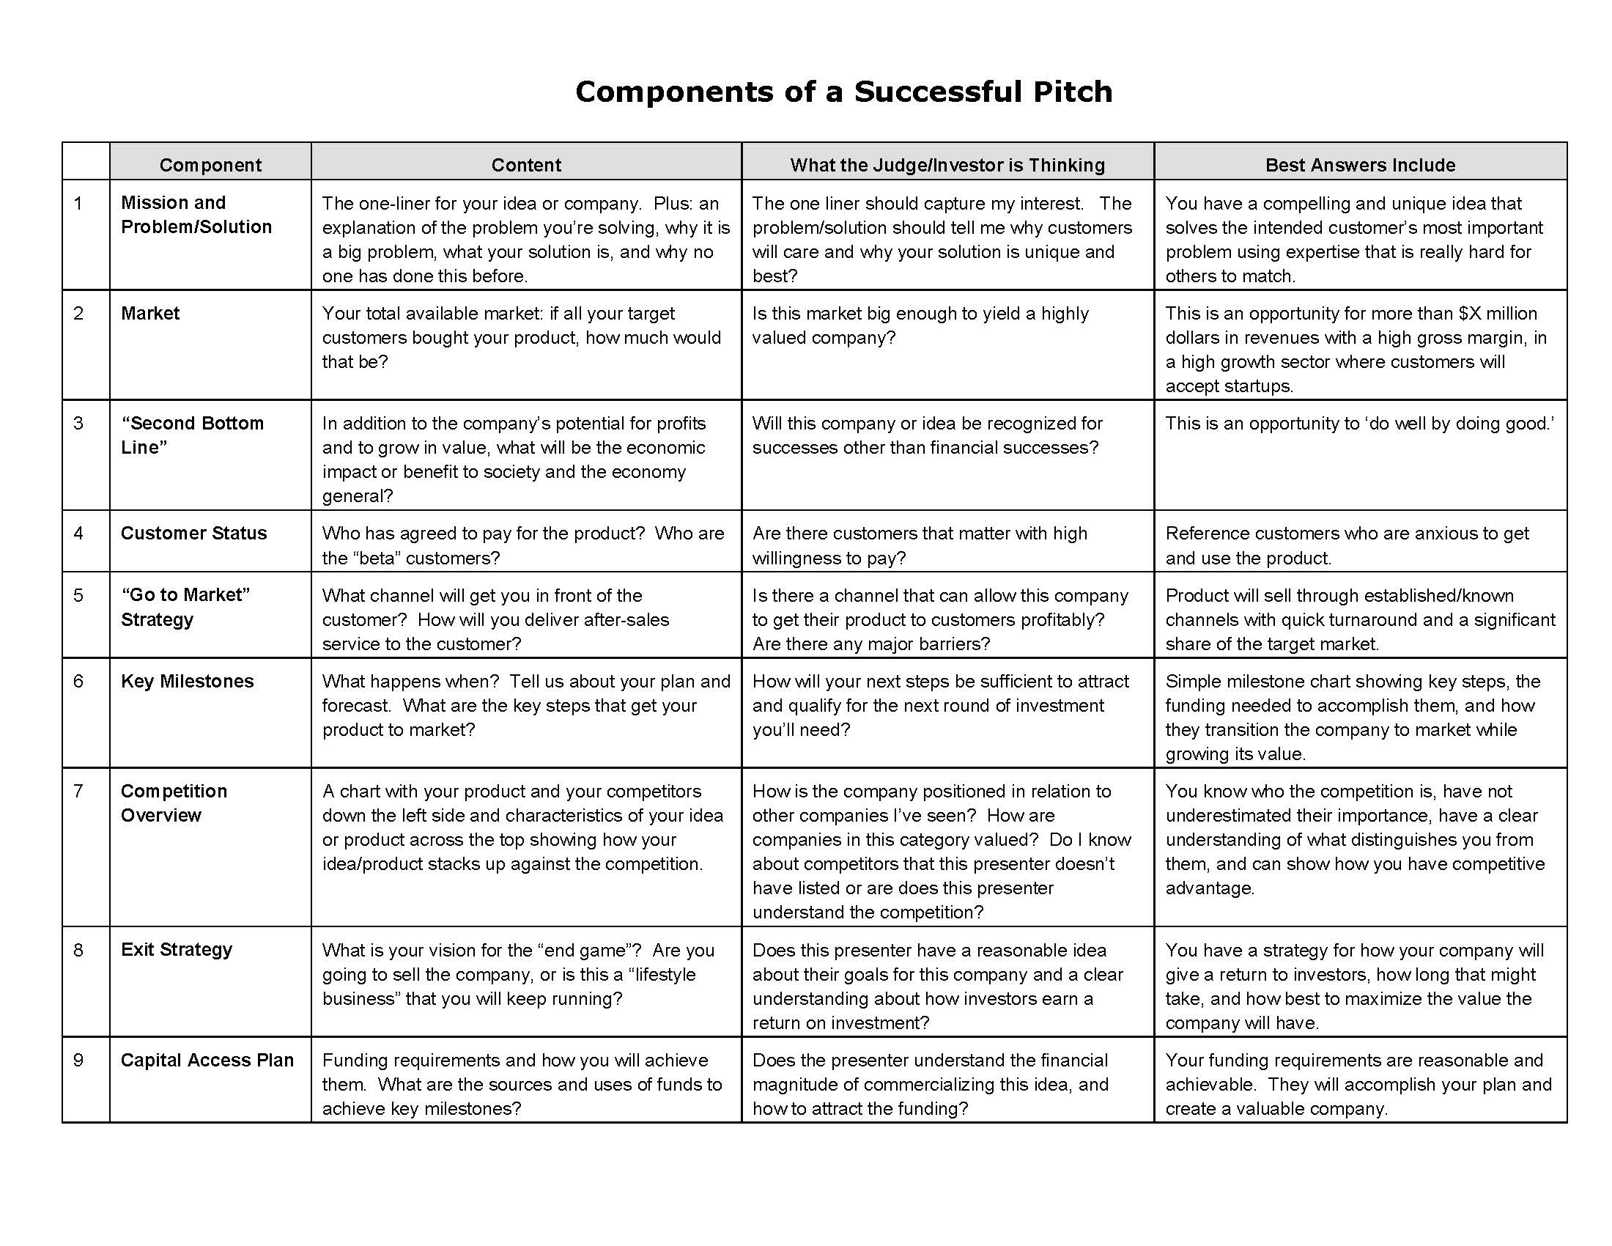
APPENDIX THREE: MATRIX

